**TM Forum Introductory Guide**

**AI Checklist Mapping in CSPs AI Ecosystems**

**IG1239**

**Team Approved Date: 02-Apr-2021**

|  |  |
| --- | --- |
| **Release Status: Production** | **Approval Status: TM Forum Approved** |
| **Version 1.0.0** | **IPR Mode: RAND** |

# Notice

Copyright © TM Forum 2021. All Rights Reserved.

This document and translations of it may be copied and furnished to others, and derivative works that comment on or otherwise explain it or assist in its implementation may be prepared, copied, published, and distributed, in whole or in part, without restriction of any kind, provided that the above copyright notice and this section are included on all such copies and derivative works. However, this document itself may not be modified in any way, including by removing the copyright notice or references to TM FORUM, except as needed for the purpose of developing any document or deliverable produced by a TM FORUM Collaboration Project Team (in which case the rules applicable to copyrights, as set forth in the [TM FORUM IPR Policy](http://www.tmforum.org/IPRPolicy/11525/home.html), must be followed) or as required to translate it into languages other than English.

The limited permissions granted above are perpetual and will not be revoked by TM FORUM or its successors or assigns.

This document and the information contained herein is provided on an “AS IS” basis and TM FORUM DISCLAIMS ALL WARRANTIES, EXPRESS OR IMPLIED, INCLUDING BUT NOT LIMITED TO ANY WARRANTY THAT THE USE OF THE INFORMATION HEREIN WILL NOT INFRINGE ANY OWNERSHIP RIGHTS OR ANY IMPLIED WARRANTIES OF MERCHANTABILITY OR FITNESS FOR A PARTICULAR PURPOSE.

TM FORUM invites any TM FORUM Member or any other party that believes it has patent claims that would necessarily be infringed by implementations of this TM Forum Standards Final Deliverable, to notify the TM FORUM Team Administrator and provide an indication of its willingness to grant patent licenses to such patent claims in a manner consistent with the IPR Mode of the TM FORUM Collaboration Project Team that produced this deliverable.

The TM FORUM invites any party to contact the TM FORUM Team Administrator if it is aware of a claim of ownership of any patent claims that would necessarily be infringed by implementations of this TM FORUM Standards Final Deliverable by a patent holder that is not willing to provide a license to such patent claims in a manner consistent with the IPR Mode of the TM FORUM Collaboration Project Team that produced this TM FORUM Standards Final Deliverable. TM FORUM may include such claims on its website but disclaims any obligation to do so.

TM FORUM takes no position regarding the validity or scope of any intellectual property or other rights that might be claimed to pertain to the implementation or use of the technology described in this TM FORUM Standards Final Deliverable or the extent to which any license under such rights might or might not be available; neither does it represent that it has made any effort to identify any such rights. Information on TM FORUM's procedures with respect to rights in any document or deliverable produced by a TM FORUM Collaboration Project Team can be found on the TM FORUM website. Copies of claims of rights made available for publication and any assurances of licenses to be made available, or the result of an attempt made to obtain a general license or permission for the use of such proprietary rights by implementers or users of this TM FORUM Standards Final Deliverable, can be obtained from the TM FORUM Team Administrator. TM FORUM makes no representation that any information or list of intellectual property rights will at any time be complete, or that any claims in such list are, in fact, Essential Claims.

Direct inquiries to the TM Forum office:

181 New Road, Suite 304

Parsippany, NJ 07054, USA

Tel No. +1 973 944 5100

Fax No. +1 973 998 7916

TM Forum Web Page: [www.tmforum.org](http://www.tmforum.org)

Table of Contents

Notice 2

Table of Contents 4

List of Figures 6

List of Tables 7

Template Reference 8

Executive Summary 9

1. Introduction 10

2. AI Checklists in nutshell 11

3. AI Checklists mapping Levels considered 12

4. How CSPs can operationalize AI Checklists in their AI Ecosystems: 13

4.1. Methodology 13

4.2. Proposed high level design for AI checklists mapping tool 13

4.3. Proposed generic CSPs AI Ecosystem as a general playground for applying the methodology 14

4.4. CSPs’ AI Ecosystem key Stakeholders (Actors) and respective Roles 15

4.5. Illustration of this “Level 0 mapping” on the AI Procurement Checklist 16

5. Mapping of AI Checklists within a CSPs AI environment when activating the whole AI life cycle 18

5.1. Proposed CSPs AI Environment 18

5.2. Main components of the CSP’s Environment and its Ecosystem 19

5.2.1. AI Model Marketplace 19

5.2.2. AI Policy 19

5.2.3. Distributed Data Lake 19

5.2.4. Training & Re-training Environment 19

5.2.5. Testing Environment 19

5.2.6. Deployment Environment 20

5.2.7. Operation Environment 20

5.2.8. CSP’s Customer 20

5.3. Mapping Process 20

6. Mapping of the 6 AI Checklists with some AI-driven use cases 21

6.1. Proposed eTOM mapping 21

6.2. Mapping with the 6 AI Checklists 22

7. How CSPs can operationalize AI Checklists in ODA (Open Digital Architecture) 23

7.1. ODA in a nutshell 23

7.2. ODA as Multi-layer AI-powered Closed Loops Framework 24

7.2.1. ODA Slow Control Loop Layer 24

7.2.2. ODA Fast Control Loop Layer 25

7.2.3. ODA Fast Control Loop Layer as support of AI-driven Business Assurance 25

7.2.4. ODA Fast Control Loop Layer as support of AI-driven Service Assurance 26

7.3. Mapping of AI Checklists with ODA as a Multi-layer AI-powered Closed Loops Framework 26

7.4. CSP’s Single ODA Instance Under AI Checklists Mapping when changing objectives 26

7.4.1. Description of the 3 steps of the Use Case 27

7.5. Federated ODAs instances Under Checklists Mapping 29

7.5.1. CSPs’ Business Scenarios behind Federated ODAs to be subjected to AI Checklists mapping 29

8. Conclusion and next steps 32

9. References 33

10. Administrative Appendix 34

10.1. Document History 34

10.1.1. Version History 34

10.1.2. Release History 34

10.2. Acknowledgments 35

10.2.1. Lead & Author 35

10.2.2. Main Contributors 35

10.2.3. Reviewers 35

10.2.4. TM Forum Staff 35

# List of Figures

Figure 1: AI Checklists in a nutshell 11

Figure 2: Proposed high level design view of AI Checklists mapping tool 14

Figure 3: A Generic CSP’s AI Ecosystem mapped with the 6 AI Checklists 15

Figure 4: AI Stakeholders in CSP’s Ecosystem as Consumers of AI Checklists 16

Figure 5: How AI Procurement Checklist can help Procurement Practitioners and Supply-Chain department 17

Figure 6: Mapping of AI Checklists within a CSP’s AI environment (Source: Orange contribution to DTWS AIOps Masterclass, November 2021) 19

Figure 7: CSP’s AI environment Under AI Check Lists Mapping 20

Figure 8: Mapping of AI Checklists with AI Closed Loop Anomaly Detection & Resolution eTOM-based Use Cases 22

Figure 9: ODA Functional Architecture (IG1167) 24

Figure 10: ODA-FA (Functional Architecture): Multi-Layer Control Loops (AI / ML) Framework (Ref IG1167/ IG1177) 25

Figure 11: CSP's ODA (Functional Architecture Under Checklists Mapping) 26

Figure 12: CSP's Single ODA Instance Under AI Checklists Mapping 27

Figure 13: Federated ODA instances (IG 1177) 29

Figure 14: Federated ODAs instances Under Checklists Mapping 31

# List of Tables

Table 1: Description of the 3 steps of the Use Case 27

# Template Reference

The AI User Story/Use Case guidebook is a model that provides an adequate view from both the user and systems view. Although there are some similarities between User Stories and Use Cases, User Stories and Use Cases are not interchangeable.  Both User Stories and Use Cases identify users, describe goals, but they serve different purposes.

The AI Use Case template helps visualize requirements from an actor-system interaction. The Use Case template is more granular and describe how system will interact.

It is recommended following along a completed example to help you fill out this use case. For more direction, please review GB1002 in its entirety: <https://www.tmforum.org/resources/how-to-guide/gb1002-artificial-intelligence-user-stories-use-cases-r19-0-0/>

# Executive Summary

In order to take advantage of AI, CSPs (Communication Service Providers) have to consider the whole AI Journey and Lifecycle Management (Procurement, Deployment and Operations through DevOps /AIOps/TestOps) as a continuum and nested feedback closed loop-driven process that should have minimal or no human intervention. That means they have to provide dynamic feedback retrospective reports regarding Explanability, Ethical related aspect to human in critical situations (High-risk applications that may cause damage to Human, Citizens, Society.). At the same time, being accountable towards the human accordingly, in such circumstances. This also means, leaving the ultimate governance, control and decision to the human.

This is the reason why, the Industry, mainly CSPs and their partners are seeking guidance / practical tools to help them in streamlining their effort in their AI journey. This is exactly the purpose of the AI Checklist Framework TM Forum developed IG1199.

The methodology adopted consists in using the Top 6 AI Checklists specified in IG1199 as the foundation and reference to the mapping exercise performed on the CSPs AI journey by considering their AI Ecosystems and supported use cases as playground. This mapping exercise is somehow an internal benchmarking study carried out by using as input relevant real use cases developed by some TM Forum projects and Catalysts in the AI space and also some Frameworks such as ODA (Open Digital Architecture), AN (Autonomous Networks).The outcome and results emerging from this mapping exercise in the course of the development of successive releases and iterations will be translated into an actionable guidance. The hope is that this will allow them to move through successive stages in the accession process.

Each actor in the CSPs AI Ecosystem, as the business owner of a given AI life cycle phase of the AI journey, may need to break down its phase into multiple sub-phases with associated tasks and sub-tasks and processes when relevant. Therefore, this may highlight, point out and show numerous pain points that make the AI journey very complex and time and OPEX consuming. Thanks to this mapping with the AI Checklists Framework, users will be able to put “Touch Points” or “Control Points” as flexible probes to facilitate assessing each Business owner phase, hence identifying duplications, redundancies even gaps and consequently acting on reducing pain points and optimizing OPEX and contributing to the value creation. Furthermore, those Business KPIs will be maximized by automating the whole AI Checklists process once each of its 6 individual Checklist are translated into a machine readable template which is the ultimate goal of the AI Checklists Framework and its usage.

This iteration (the current release) is the first instance of this AI Checklists Framework operationalization and mapping exercise. It is an exploratory work that will pave the way for the next iterations in the next sprints that will provide consolidated and mature guidance to the CSPs and their partners in the AI space thanks to this AI Checklists instrument.

# Introduction

Section 1 provides a quick summary to the reader not familiar with the AI Checklists Framework IG1199 which is the pre-requisite to understand the other sections that elaborate the mapping and usage of this AI Checklists Framework on various contexts which is the main goal of this document. Section 2 sets out the two proposed AI Checklists mapping Levels namely “Level 0 mapping” (high level mapping) which is the target of this current version.  “Level 1 mapping” consists of drilling down into the mapping exercise and will be considered in the next versions (releases) of this document. Section 4 is dedicated to answering the question of How we can help CSPs operationalizing the AI Checklists in their AI Ecosystems. Section 5 focuses on mapping of the AI Checklists within a specific CSP’s AI environment for illustration. Section 6 addresses the mapping of AI Checklists with some use cases with a special focus on use cases pertaining to Cognitive (AI-driven) Business Assurance and Cognitive (AI-driven) Service Assurance as art of Business Process (eTOM) Framework.  Section 7 addresses the question of how CSPs can operationalize AI Checklists in ODA Functional Architecture Framework as specified in (IG1167).

Finally, Section 8 concludes this work by setting out the proposed next steps and further work to be performed in the next iterations (sprints).

# AI Checklists in nutshell

Figure 1 is a quick reminder to the reader about the AI Checklists Framework. It is a pre-requisite to the next sections. For more details, the reader is invited to read IG1199.

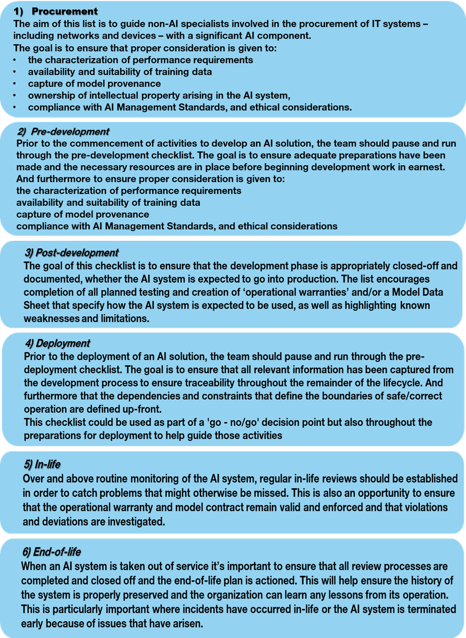

Figure : AI Checklists in a nutshell

# AI Checklists mapping Levels considered

To ease the mapping process, we assigned a number to each AI Checklist as indicated in Figure 1.

The following two mapping Levels are proposed:

* *Level 0 mappin*g

In the scope of the current Release of this document, the focus regarding the mapping exercise is on the tagging process - positioning each AI Checklist number at the right Entity of considered AI Ecosystem/ Environment as a playground for the mapping exercise.

* *Level 1 mapping*

The next release will address AI Checklist “Level 1”. This means the opening of each of the 6 AI Checklists and drilling down into the prescribed and described items list they contain and perform the mapping at such a level.

# How CSPs can operationalize AI Checklists in their AI Ecosystems:

## Methodology

To operationalize and mechanize the 6 AI Checklists, there is a need for performing benchmark studies by instantiating (IG1199) onto selected use cases demonstrated in various contexts such as AI Closed Loop driven Business Assurance, AI Closed Loop Service Assurance carried out by CSPs internally or through Catalysts. As a new TM Forum Framework, the AI Checklists Framework needs to be hooked and mapped to existing Frameworks when relevant. In this regard, the ODA (Open Digital Architecture) was selected as a Multi-layer AI Closed loops Framework as a first candidate in this first release. While there is currently substantial cross-mapping work involving ODA, SID, Business Capabilities, Open APIs, Business Process (eTOM) and Application Framework (TAM), the intention, in this release, is not to enter in this E2E mapping work. These topics will be considered in the next Releases.

## Proposed high level design for AI checklists mapping tool

Figure 2 proposes a high level design view of AI Checklists as a tool that supports the methodology presented in Section 4.1. The implementation and governance / administration and ownership of such a tool is out of scope of this iteration.

The architecture of tool contains the following components:

* Validor module. It is a kind of a Search Engine (could be powered by AI capabilities) for matching CSPs AI life cycle Operation Master Plan requirements as candidate  and input to the mapping process.
* Assessment module. It delivers the result regarding the CSPs AI life cycle Operation Master Plan requirements mapping. This assessment result is exposed under three options (1. Passed / green score; 2. Not passed / red score; 3. Partly passed / orange score).
* TM Forum 6 AI Checklists as developed in IG1190 / GB1021 is the reference of the tool and key component

The CSPs AI Ecosystem as input (candidate) for mapping and assessment process and to be subjected to the AI Checklists tool

* CSPs AI life cycle Operation Master Plan requirements
* CSPs immediate assessment result analysis module. Its analysis in near real-time or on-the-fly, the assessment results (scores)
* CSPs retrospective assessment result analysis module. It analyzes the results (scores) and associated reports and then derives actions/recommendation to improve, adjust and update its AI life cycle Master Plan requirements. It allows assessing the benefit gained by leveraging the TM Forum AI Checklists Framework as a standard.

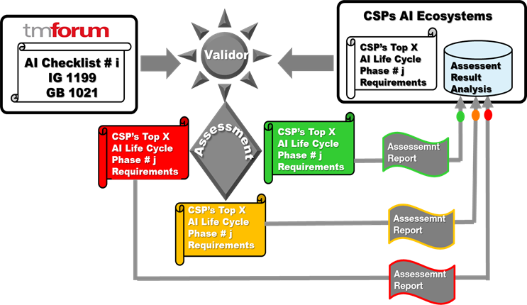

Figure : Proposed high level design view of AI Checklists mapping tool

## Proposed generic CSPs AI Ecosystem as a general playground for applying the methodology

Figure 2 depicts a diagram view that could reflect a CSPs AI Ecosystem that will serve as a playground for our AI Checklists mapping exercise.

**Internal stakeholders and related Department and their interactions**

* Procurement Department and Procurement Practitioners.  “Procurement Practitioners are shown as key stakeholder surrounded by internal and external Entities of the CSPs AI Ecosystem.
* AI Strategy Department (Digital Transformation Team, CDP, CIO, CNO, CTIO,..).  Provides the CSPs requirements on AI Strategy and on Business policies
* AI Operational Department (Data Management Team, Deployment Team and Operations Team). Provide operational policies and operational requirements
* Internal Interactions. These interactions are depicted by the green arrows

**External stakeholders and related Entities**

* Independent AI Tester and Independent AI Certifier.
* AI Models Suppliers / Developers / Marketplace
* External Interactions. These interactions are depicted by the blue arrows (with AI Suppliers / Marketplace) and black arrows (with Independent AI Tester and Independent AI Certifier).

**Generic CSP’s AI Ecosystem mapped with the 6 AI Checklists**

In this mapping exercise, only “Level 0 mapping” was considered as it is defined in Section 3.

In Figure 3, each of the 6 AI Checklists are positioned at the right of the CSPs Entity of its AI Ecosystem. Notice that a given AI Checklist may be positioned at more than one Entity as depicted in the diagram.

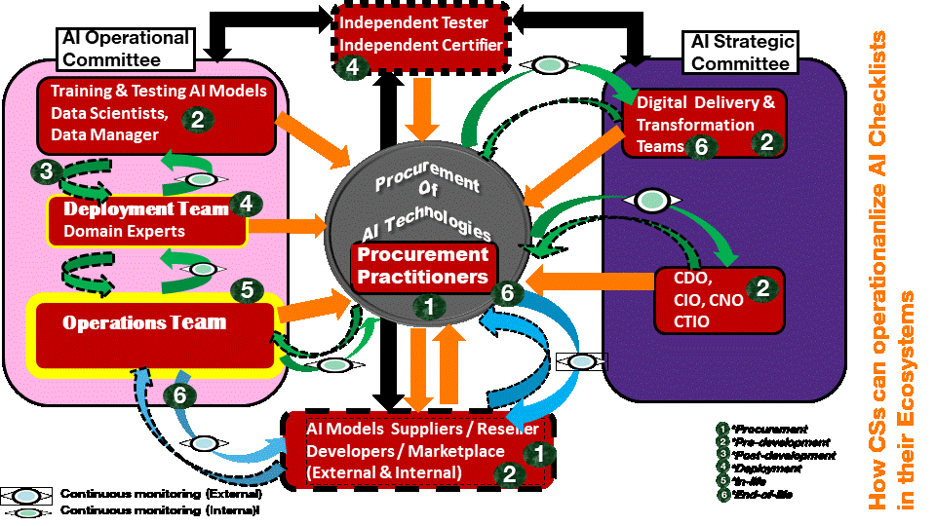

Figure : A Generic CSP’s AI Ecosystem mapped with the 6 AI Checklists

## CSPs’ AI Ecosystem key Stakeholders (Actors) and respective Roles

Figure 4 identifies the key Stockholders (Actors) and their respective Roles, Duties and Responsibility demarcation involved in the CSPs AI Ecosystem and AI journey. They are potential consumers of the 6 AI Checklists. The Regulator was not included as an explicit actor in Figure 4, however, it was preferred in assessing the enforcement of the recommendations issued (and their continuous updating) as stated and adapted in the AI Checklists. Such Legislations / Regulations on AI are produced by the European Commission **[]** and other similar Organizations. The essence is already captured in the AI Checklists Framework IG1199 and will be updated after AI Checklists mapping either by feedback from CSPs or when additional and new recommendations are issued by those Organizations and Institutions (International and National).

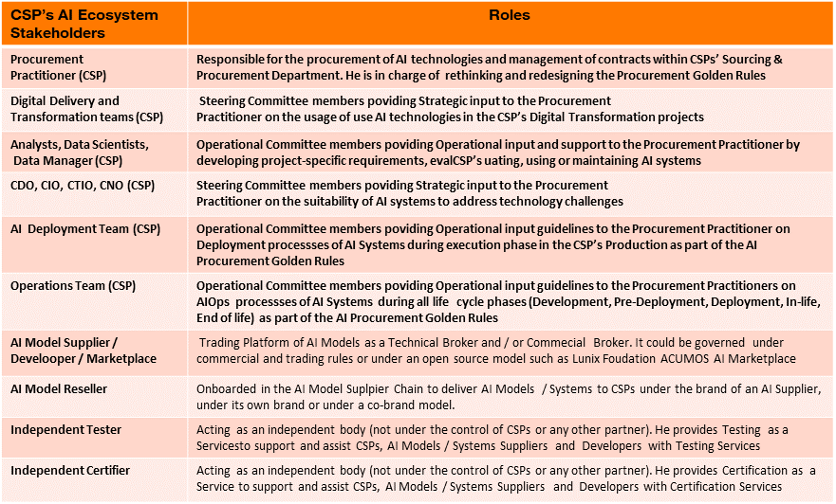

Figure : AI Stakeholders in CSP’s Ecosystem as Consumers of AI Checklists

## Illustration of this “Level 0 mapping” on the AI Procurement Checklist

In this illustration, CSPs AI Golden Rules are subject to the AI Checklists mapping. Figure 5 aims at showing the process (only) of such a mapping of one specific AI Checklist. The mapping table to be created contains at left hand side the AI Procurement Checklist template as the reference. The exercise will consist in tracking the CSPs AI Golden Rules the Procurement Practitioner of the CSP created, then we compare and contrast the items within the AI Golden Rules template against the AI Procurement Checklist items then identify if there is any gap or deviation. This mapping exercise must be also performed at AI Model Suppliers/ Marketplace side as depicted in Figure 5. The goal is to verify that none of the AI Procurement Checklist items are missing in the CSPs AI Golden Rules. It should be noted that AI Procurement Checklist objective is not to substitute the AI Procurement Practitioner work. It must be seen as a “validor” providing an assessment that the mandatory requirements regarding AI Procurement are or not covered by the CSPs AI Golden Rules.

The intent in the next releases of this document is to elevate this illustration as a dedicated specification as was done in TM Forum **[IG1133 series, IG1141]** when virtualization / softwarization technology emerged as a hot topic in the Telco industry.  CSPs Procurement & Supply Chain and Software Asset Management departments are expecting similar guidance from Software Developing Organizations (SDOs) in the (re)shaping, updating, improving their “AI Golden Rules” and related processes. Therefore, TM Forum AI Checklists Framework is aimed at contributing to this expected answer.

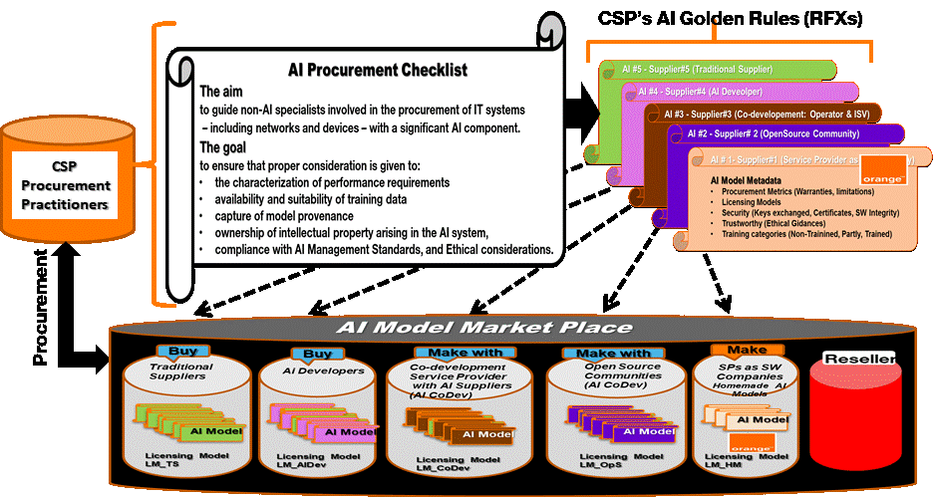

Figure : How AI Procurement Checklist can help Procurement Practitioners and Supply-Chain department

# Mapping of AI Checklists within a CSPs AI environment when activating the whole AI life cycle

## Proposed CSPs AI Environment

In order to take advantage of AI, CSPs have to consider the whole AI Journey and  lifecycle Management (Procurement, Deployment and Operations through DevOps /AIOps) as a continuum and nested feedback closed loop-driven process that should have minimal or no human intervention while providing explainability to human in critical situations and being accountable towards the human accordingly. This also means, leaving the ultimate governance and control to the human.

No part of the CSPs AI Journey phase should become a bottleneck in this agile life cycle, nor jeopardize the promises of AI. Even if an AI Model is simply a piece of Software that has to leverage the huge experience in Virtualization in the IT and Network space, as a matter of fact, onboarding properly an AI Model is not an easy task. This is linked to non-deterministic characteristics of the AI Model that may exhibit an expected behavior at run-time that it is not easy to control, and also AI Model is very sensitive to the input data. More detail can be found in IG 1190, IG 1199.

An AI Model is basically a Software like a VN/CNF, therefore, we can capitalize on the lessons learned from the TM Forum assets, Catalysts and experience on VNF/CNF Onboarding Lifecycle Management (OLM). However, an AI Model is 'special' Software characterized by additional attributes that need to be taken into consideration in redesigning the AI-driven life cycle process. Moreover, because AI is new for all thestakeholders in the digital transformation process and is about to deeply reshape the Telco Industry as well, sustainability needs to be assessed too. AI Mo*de*l life cycle Management may require more complex ecosystem integration (vertical and horizontal) by moving from simple Software Buyer-Seller segmentation model towards more integrated supply networks where new stakeholders (e.g., Data Owners, Data Scientists, Domain Experts, Accountability/ Ethical, Tester, Certifier, Legislation / Regulation “Keepers”, ...)  can be onboarded. At the same time, additional processes (e.g., (re)-training, dataset preparation, Data verification, Accountability, Ethical, Legal / Regulatory obligations verification ...) can be triggered.

Those processes become more challenging for Online AI Models that are directly deployed in the CSPs Production environment hence exposed to real data and immediately triggering and performing continuous learning, continuous testing, and continuous Accountability. This will impose more deep investigations, to reduce pain points associated with impact of the input Data and also to meet all the new Legislation / Regulation related requirements. This is the reason why the AI Checklists Framework is a valuable instrument to optimize AI Model life cycle management in a CSP’s environment, such as the one proposed in Figure 6 that illustrates a real use case on AI Closed Loop Anomaly Detection Automation and Resolution for Fiber To the Home (FTTH) service and its articulation with AIOps Incident Management as described in IG1190 G/H. This use case is described in TR 284 .

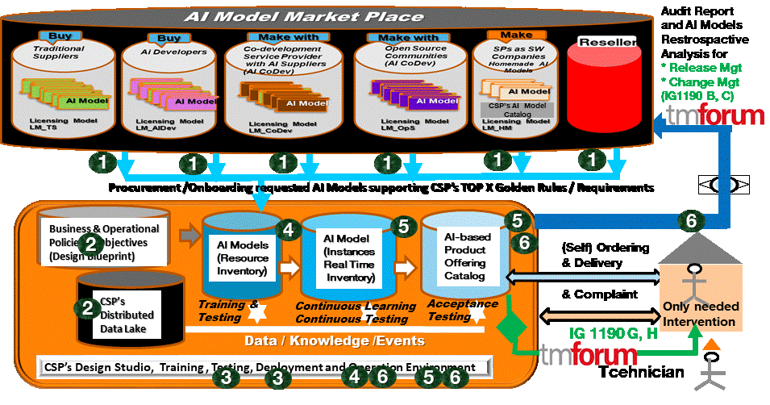

Figure : Mapping of AI Checklists within a CSP’s AI environment (Source: Orange contribution to DTWS AIOps Masterclass, November 2021)

## Main components of the CSP’s Environment and its Ecosystem

### AI Model Marketplace

* It stores Suppliers’ AI Models made available to CSPs for onboarding, procurement. User's should consider the 5 categories of AI Model Suppliers along with Resellers that can interact with all of them playing the role of a “Proxy” or Commercial Broker as shown in Figure 6.

### AI Policy

* Generator of Policies (Business and Operational);
* Validators of Policy against conflicts that might happen.

### Distributed Data Lake

* Collecting and storing all kinds of data, Telemetry Data, historical Data, Streaming Data and Event data related to network (Networks functions, Network Elements, IT Systems, Management Systems), customers, marketing research studies, Business Intelligence, complex events and all kinds of data sources from external sources (e.g., social media)
* Processing, analyzing data

### Training & Re-training Environment

* Once Data is curated it is split into a Data Set for training and Data set for testing. The former is used as input to train AI Models.

### Testing Environment

* Once Data is curated it is split into a Data Set for training and Data set for testing. The latter is used as input to test AI Models (Functional and Non-functional testing)

### Deployment Environment

* Once the Model is trained and tested it is exposed to new data set

(real-time data that are different from historical data used to train the AI Model) with Business and Operational Policies, and creating instances of various AI Models, chaining them to achieve the desired global objective, before declaring this 'chain' ”Operation-Ready”.

### Operation Environment

* The AI Models instances are exposed to real data. In this environment, the performance of AI Models and its execution environment are tracked and monitored and updated removed/ changed when needed thanks to probing tools or other means.

### CSP’s Customer

* Customer self-orders via an API the AI-based services from CSP’s Portal and Product Offering Catalog. The customer's role in the Life cycle process as a consumer is to perform acceptance testing of Product offerings ordered and to provide feedback to the CSP.

## Mapping Process

This mapping exercise considers “Level 0 mapping” only as it is defined in section 3.

In Figure 7, each of the 6 AI Checklists are positioned at the right CSPs Entity of its AI Ecosystem. Notice that a given AI Checklist may be positioned on more than one Entity as depicted in the diagram (Figure 7).

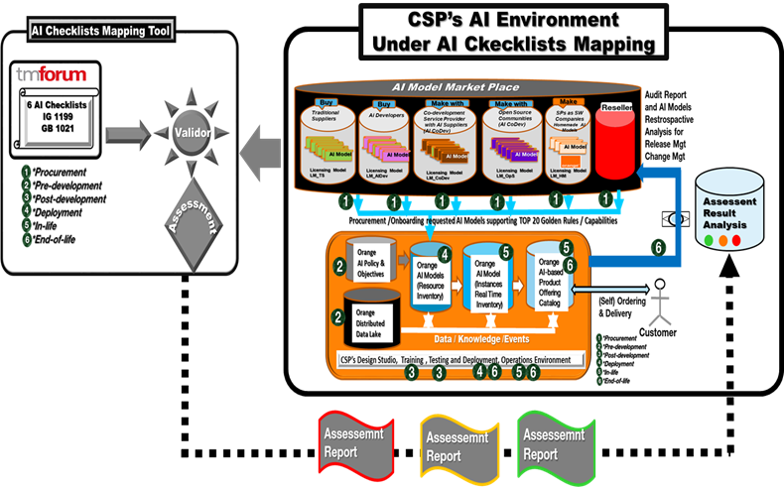

Figure : CSP’s AI environment Under AI Check Lists Mapping

# Mapping of the 6 AI Checklists with some AI-driven use cases

In this section, the main focus is on AI-driven use cases pertaining to Cognitive (AI-driven) Business Assurance and Cognitive (AI-driven) Service Assurance. The “AI-driven” term and Cognitive term are used interchangeably to reflect on different terminologies and taxonomies used by various SDOs. The term “Cognition” used by ETSI GANA Framework **[ETSI TS 103 159-2},** in particular, refers to “Learning and Reasoning”. The motivation behind choosing those two categories of use cases is that they provide good coverage of the TM Forum eTOM Framework which is largely adopted by the Industry. Other use cases covering other processes and Frameworks could be considered in the next iteration of this document if needed.

## Proposed eTOM mapping

**Considered eTOM (Business Process) Verticals**: Strategy Management, Infrastructure Life Cycle, Product Life Cycle, Operations Management (Operations & Readiness, FAB)

* All Verticals are considered with a broader scope to Operations Management

**Considered eTOM (Business Process) Horizontals:** Market & Sales, Party, Products, Services, Resources

* Services, Resources mainly, but Party, Product and Market & Sales  could be considered for some Use Cases that may cross all the Horizontals

**AI Closed Loop-driven Business Assurance Anomaly Detection & Resolution Automation**

* *Use Stories pertaining to AI Closed Loop-driven Business Assurance*

This category list can include: Churn Management which includes Leakage Management, Subscribe Churn and Forecasting & Capacity, Offer Design, Revenue Management.

**AI Closed Loop-driven Service Assurance (Anomaly Detection & Resolution Automation**

* *Use Stories pertaining to  AI Closed Loop-driven Service  Assurance*

This category list can include: Network Management which includes Forecasting & Capacity, Offer Design, Revenue Management

**Considered Processes**

* Process Flow
* Diagram Flow
* Event Flow
* ODA analytical and operational processes
* Business processes

**Architecture considered**

* AI Closed Loop Anomaly Detection & Resolution Automation “Logical Architecture” based on OODA

(Observe, Orient, Decide, Execute) Framework  to be then  instantiated onto Physical Architectures per proposed Real implemented Use Case as specified in TR 284.

## Mapping with the 6 AI Checklists

This mapping exercise considers “Level 0 mapping” only as it is defined in Section 3.

Figure 8 positions each of the 6 AI Checklists at the right CSP’s Entity of its AI Ecosystem. Note that a given AI Checklist may be positioned at more than one Entity as depicted in the diagram (Figure 8).

In this section, we perform Level 0 mapping on the  two listed use cases classified below in two families:

* Use cases pertaining to AI-Closed Loop-driven Business Assurance (illustrated with the green rectangle)
* Use cases pertaining to AI-Closed Loop-driven Service Assurance (illustrated with the blue rectangle)

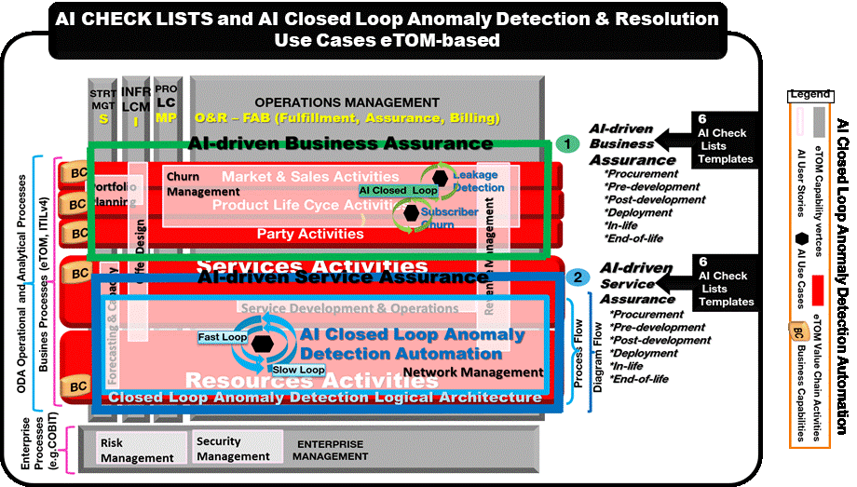

Figure : Mapping of AI Checklists with AI Closed Loop Anomaly Detection & Resolution eTOM-based Use Cases

The next releases will consider each individual Use Cases as described in IG1229, in order to be subject to AI Checklists mapping.

# How CSPs can operationalize AI Checklists in ODA (Open Digital Architecture)

This section addresses the Operationalization of AI Checklists and mapping process in ODA as a “Multi-layer AI-powered Closed Loop Framework” from the three following perspectives that are of high interest to CSPs:

* ODA Functional Architecture specified in IG1167 as the new CSPs’ Intelligent Digital Platform Framework”
* ODA single instance operationalization within the whole process when moving from Design phase to Execution (run-time) phase as described in IG1177 (ODA Intelligence Management Implementation Guide)
* Federated ODAs instances operationalization within the whole process when moving from Design phase to Execution (run-time) phase as described in IG1177 (ODA Intelligence Management Implementation Guide). Those federated ODA instances may belong to the same CSP or to multiple CSPs (Inter-Carrier model).

## ODA in a nutshell

In order to accommodate readers’ various perspectives in terms of concept and taxonomy, Figure 9 combines the well-known “Systems view” concept with “ODA Functional Architecture view” (5 Blocks/Colors) and also “Business view”. Figure 9 depicts these various views. More details about ODA Functional Architecture can be found in IG1167.

* **Systems of Engagement** (Front ends) that deal with User Interface sequences & interactions with the outside (with relevant security policies). It is reflected by *ODA Engagement Management Functional Block. It does not contain Processes, Data.*
* **Systems of Records** (Back end) in charge of Business processes. It is composed by the three following ODA Functional Blocks *(Party Management, Core Commerce Management, and Production). They contain Operational Processes.*
* **Systems of Insights** (Back End systems) in charge of Analytical processes and insights on the enterprise activity. It is reflected by *ODA Intelligence Management Functional Block.*

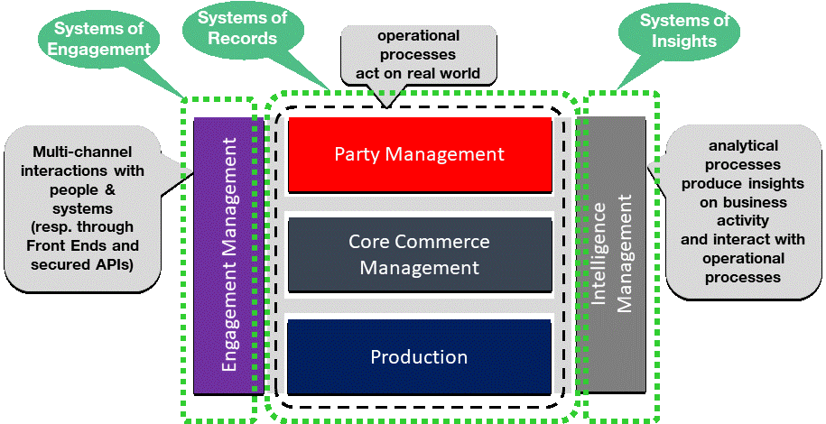Figure : ODA Functional Architecture (IG1167)

## ODA as Multi-layer AI-powered Closed Loops Framework

Within CSPs space, there are various processes and life cycles nested and interworking at various time-scales (Fast time-scale and Slow time-scale). ODA Intelligence Management has the purpose of managing design and operational processes associated with Autonomic and Cognitive capabilities (Closed Control-loops for management and control of Network and Services) and behaviors. As such, ODA Intelligence Management shall adopt design principles that accommodate and combine both time-scales ("Fast time-scale" and "Slow time-scale") in an interworking manner in a "Hybrid" Model. Hence, this ODA design principle defines time-scaling for such capabilities at various levels of abstraction of self-management functionality. It is an adaptation of ETSI GANA (Generic Autonomic Networking) Framework specified in ETSI TS 103 195-2.

### ODA Slow Control Loop Layer

“Macro” Autonomic Managers or DE (Decision making Elements) as AI / ML Models (responsible for Centralized Closed Control-loops) that drive logically centralized ODA-wide control-loops but operate at "Slower time-scale". As depicted in Figure 10, they are implemented in the “Intelligence Management” Functional Block through the “ODA Knowledge Plane” that can be seen as an evolution of a Management Plane or Control Plane embedding Intelligent and Cognitive capabilities. It is the Brain for Implementers to design and Implement Advanced Cognitive Management & Control DE Algorithms (not subject to standardization) to allow them to differentiate each other and make those Algorithms available to CSPs to select / choose / purchase the Best-in Class solutions and upload / replace over time independently as microservices.

This ODA Slow Control Loop Layer policy-controls the ODA Fast Control Loop Layer.

### ODA Fast Control Loop Layer

"Micro" Autonomic Managers or DE (Decision making Elements) as AI / ML Models that drive control-loops .

(similar to ODA Slow Control Loops) that can be implemented in a distributed fashion for local reactions that operate at "Faster time-scale". They are implemented in the three following ODA Function Blocks as depicted in Figure 10.

* *Yellow fast Closed Control loop) or AI / ML / Cognitive Business (CRM): “Party Management Closed Control Loop” with its “Business & Marketing” CRM Knowledge Base and its “Decision-Making Logics” (AI Algorithms e.g., those provided by the industry, …)*
* *Orange fast Closed Control loop or AI / ML / Cognitive Business (Flexible Offer & Business Assurance): “Core Commerce Management Closed Control Loop” with its “Business & Marketing” Knowledge Base and its “Decision-Making Logics” (AI Algorithms e.g., those provided by the industry,…)*
* *Green fast Closed Control loop or AI / ML / Autonomics / Cognitive Service Assurance: “Production Closed Control Loop” with its "Resource & Service” and its “Decision-Making Logics” (AI Algorithms)*

This ODA Fast Control Loop Layer is policy-controlled by the ODA Slow Control Loop Layer.

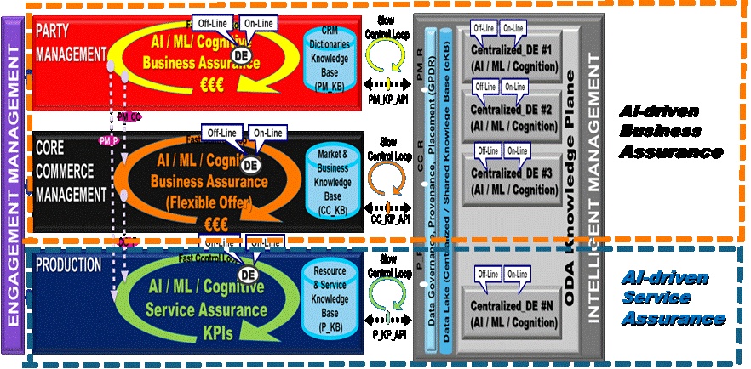

Figure : ODA-FA (Functional Architecture): Multi-Layer Control Loops (AI / ML) Framework (Ref IG1167/ IG1177)

### ODA Fast Control Loop Layer as support of AI-driven Business Assurance

Figure 10 reflects the way that ODA Fast Control Loop Layer can support AI-driven Business Assurance Use Cases. They can be implemented and Self-managed in ODA Party Management and in ODA Core Commerce Management Functional Blocks and policy-controlled by ODA Knowledge Plane. The red dotted rectangle shows the Responsibility demarcation of the AI-driven Business Assurance perimeter.

### ODA Fast Control Loop Layer as support of AI-driven Service Assurance

Figure 10 also reflects the way that ODA Fast Control Loop Layer can support AI-driven Service Assurance Use Cases. They can be implemented and Self-managed in the ODA Production Functional Blocks and policy-controlled by ODA Knowledge Plane. The blue dotted rectangle shows the responsibility demarcation of the AI-driven Service Assurance perimeter.

## Mapping of AI Checklists with ODA as a Multi-layer AI-powered Closed Loops Framework

In this mapping exercise, Level 0 mapping is considered only as it is defined in section 3.

In Figure 11, each of the 6 AI Checklists is positioned at the right CSPs Entity of its AI Ecosystem. A Given AI Checklist may be positioned at more than one Entity as depicted in Figure 11.

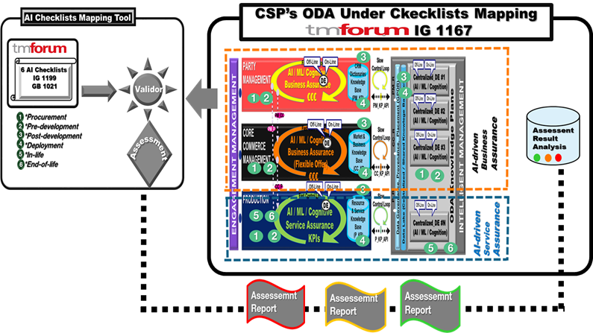

Figure : CSP's ODA (Functional Architecture Under Checklists Mapping)

## CSP’s Single ODA Instance Under AI Checklists Mapping when changing objectives

Figure 12 uses the choreography of the Analytics-driven Autonomics journey on a single ODA instance as described in IG 1177 (ODA Intelligence Management Implementation Guide).

It shows an ODA instance composed of the five ODA Functional Blocks as depicted in Figure 10. The top of the figure shows a DE (AI Model) Marketplace that could be one player in this Intelligence Management Ecosystem along with DEs (Algorithms) / Implementers / Developers /Suppliers). In this use case, ODA Intelligence Management Knowledge Plane needs to procure three specialized Centralized DEs (c_DEs / AI Models) namely: Energy “c_DE” (AI Model) QoS “c_DE” (AI Model) and Resilience “c_DE” (AI Model). In the same way, ODA Production needs to procure the same specialized DEs but as Distributed DEs (d-DEs) to be embedded in it. As highlighted in section 7.2, those ODA Knowledge Plane “c_DEs / AI Models” policy control the ODA Production “d_DEs / AI Models”.

The ODA’s owner (e.g.  a CSP) first onboards the Marketplace or the selected DEs (Algorithms) Developer / Implementer / Supplier if this actor does not exist yet in the CSP’s Suppliers base. Then the CSP launches the following processes: Discover, Query, Find, Train, Test and Certify the required six DEs (3 “c_DEs” and 3 “d_DEs”). Then those 6 DEs / AI Models as Marketplace’s “Products” will be onboarded in the CSP’s ODA “Resource” inventory, then become “resources” to be managed during the whole operations life cycle.

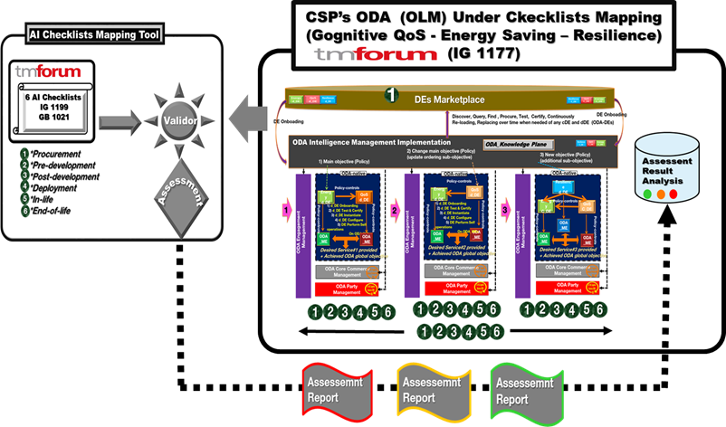

Figure : CSP's Single ODA Instance Under AI Checklists Mapping

### Description of the 3 steps of the Use Case

Table 1 captures the characteristics of each of the three steps of the Use Case

* Objective & Policy
* Execution (Run-Time) phase performed Actions
* Result (desired service)

Table : Description of the 3 steps of the Use Case

| **Use Case Steps** | **Objective & Policy** | **Execution (Run-Time) phase performed Actions** | **Result (Desired service)** |
| --- | --- | --- | --- |
| Step 1 | Dynamic and adaptive optimization of the Energy saving while meeting QoS requirements | * Interaction of CSP with AI  DE Marketplace * To procure QoS DE (AI Model) and Energy Saving DE (AI Model) * 1) d_DE Onboarding * 2) d_DE Train, Test & Certify * 3) d_DE Instantiate * 4) d_DE Configure * 5) d_DE Perform Self operations on ODA_MEs | * Desired Service#1 provided and achieved ODA global objective. * Managed Entities are designed to provide CFSs (Customer Facing Services) an input or to the ODA * Core Commerce Functional Block to build Products and Product Offerings |
| Step 2 | Dynamic and adaptive optimization of the QoS while meeting Energy saving assigned threshold | * 1) d_DE Onboarding * 2) d_DE Train, Test & Certify * 3) d_DE Instantiate * 4) d_DE Configure * 5) d_DE Perform Self operations on ODA_MEs * Desired Service#2 provided and achieved ODA global objective.. * Managed Entities are designed to provide an input or CFSs (Customer Facing Services) to the Core Commerce Function Block to build Products and Product Offerings |  |
| Step 3 | Along with the Objective and Policy defined of step 2, a new higher Objective is added w.r.t. Resilience | This requires procuring a Resilience “c_DE (AI Model) that it has   policy-controls already deployed Energy Saving “d_DE” (AI Model) and QoS “d-DE (AI Model) and at the same time, each of which has to policy-control its assigned Managed Entities  (1) d_DE Onboarding   * 2) d_DE Train, Test & Certify * 3) d_DE Instantiate * 4) d_DE Configure * 5) d_DE Perform Self operations on ODA_MEs | * Desired Service#3 provided and achieved ODA global objective.. * Managed Entities are designed to provide an input or CFSs (Customer Facing Services)  to the Core Commerce Function Block to build Products and Product Offerings |

## Federated ODAs instances Under Checklists Mapping

### CSPs’ Business Scenarios behind Federated ODAs to be subjected to AI Checklists mapping

Most Business and Technical scenarios within E2E Federated ODAs deal with responsibility demarcation at ODA infrastructure at Network Slice level delivered as CFSs by ODA Production Functional Block or at Orchestration level cross domains (e.g., Business Scenarios described in IG 1152 is an example).

In this document, the demarcation is addressed from Federated “Intelligence Management” perspective as described in IG1177, when multiple ODA instances are interacting within a global process of decision making from various perspectives as illustrated in Figure 13. This demarcation could be set statically but more often dynamically according to dynamic policy and dynamic design principles that lead to achieving conflict-free Autonomic Architecture per design as specified by ETSI TS 103 195-2 that inspired ODA Intelligence Management as described in IG1167 and IG1177.

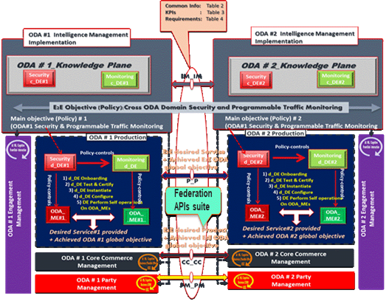

Figure : Federated ODA instances (IG 1177)

In regarding the Federation Reference Point, CSPs seek a common / generic set of information and KPIs to be exchanged at the touch points (Reference points or responsibility demarcation border) whatever the use case considered. This information and KPIs / shared negotiated Policies Thread models and associated operations / primitives need to be defined in a common and shared manner.  It also helps reducing pain points, simplifying design processes and facilitating performance assessments and benchmarking. Of course, such generic / common Information and KPIs will be complemented by specific ones once instantiating this generic Federated Framework onto a given existing or a newly designed architecture. In this iteration we just wanted to highlight that the Federated touch points specification as described in detail in IG1177, is also subject to AI Checklist mapping process without drilling down into the detail.

CSPs seek a federated model for interactions, cooperation and coordination between Peer ODA_DEs (AI Models) at ODA_ Knowledge Planes belonging to different ODA instances. Figure 13 (right hand side) extracted from IG117 represents such federated model aligned with ETSI Federated GANA (Generic Autonomic Networking Architecture) Framework [ETSI TS 103 195-2]. The information between peer ODAs may require security and trust mechanisms within references points shown in Figure 13.

**7.5.2) CSPs’ Business Scenarios behind Federated ODAs to be subjected to AI Checklist mapping**

Unlike the previous scenario, “CSPs Single ODA Instance Under AI Checklists Mapping” described in Figure 11, the Federated ODAs scenario (involving two ODA instances) is subjected to 4 separate verdicts (mapping) as shown in Figure 14:

* ODA instance #1 Under AI Checklist
* ODA instance #2 Under AI Checklist
* E2E Cross-ODA domain Under AI Checklist
* Federation Touch Point / Reference Points Under AI Checklist

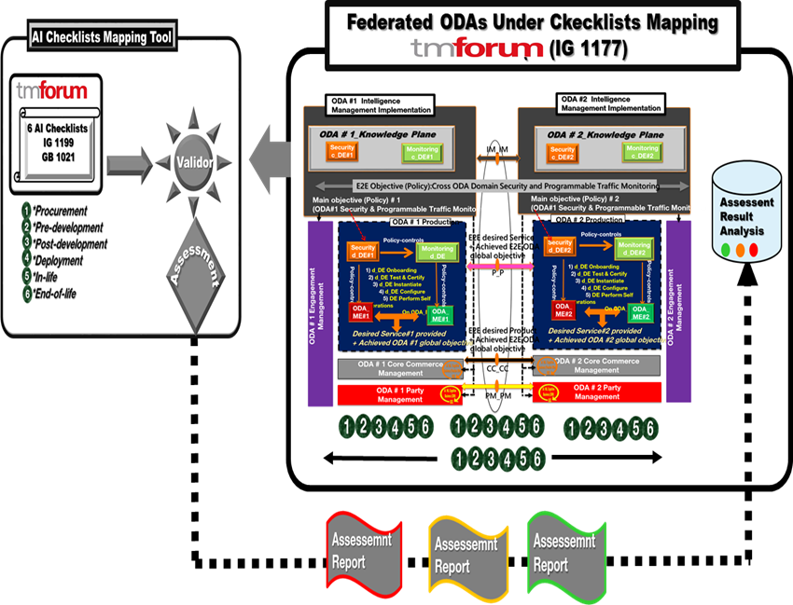

Figure : Federated ODAs instances Under Checklists Mapping

The Inter (Federated)-Domain Business scenarios either within a single Organization (CSP) or cross CSPs (Inter-Carrier scenario, such as roaming scenarios) need further elaboration from AI Checklists (e.g., a specific / dedicated AI Checklist).

# Conclusion and next steps

This release proposes two AI Checklists mapping Levels namely “Level 0 mapping” (high level mapping) which is the target of this current version and “Level 1 mapping” consists of drilling down into the mapping exercise and will be considered in the next versions (releases) of this document. A high level design view of AI Checklist mapping tool was proposed to answer the question of 'How can we help CSPs operationalizing the AI Checklists in their AI Ecosystems?'. This mapping exercise was illustrated by putting the focus on specific CSPs AI environments and use cases pertaining to Cognitive (AI-driven) Business Assurance and Cognitive (AI-driven) Service Assurance within the ODA Functional Architecture Framework space. The next iteration will be dedicated to Level 1 mapping. That means the selected CSPs AI environments and use cases will be subject to the AI Checklist Level 1 mapping but additional CSP AI environments such as Autonomous Networks Frameworks and use cases could be onboarded. A special study will be dedicated to a deep dive of Level 1 mapping on AI Procurement Golden Rules to help CSPs AI Procurement Practitioners.  In addition, the Inter (Federated)-Domain Business scenarios either within a single Organization (CSP) or cross CSPs (Inter-Carrier scenario, such as roaming scenarios) as described in section 7.5 need further elaboration from AI Checklists (e.g., a specific / dedicated AI Checklist).

# References

[ETSI  TS 103 195-2 (GANA) Generic Autonomic Networking Architecture](https://www.etsi.org/deliver/etsi_ts/103100_103199/10319502/01.01.01_60/ts_10319502v010101p.pdf)

[GB1002 Artificial Intelligence User Stories and Use Cases R19.0.1](https://www.tmforum.org/resources/how-to-guide/gb1002-artificial-intelligence-user-stories-use-cases-r19-0-0/)

[GB1021 AI & DA Management Standards Guidebook: AI Checklists v1.0.0](https://www.tmforum.org/resources/how-to-guide/gb1021-ai-da-management-standards-guidebook-ai-checklists-v1-0-0/)

[IG1129 Product Lifecycle Management (PLM): Comparison of Traditional and Virtualized PLM R15.0.0](https://www.tmforum.org/resources/exploratory-report/ig1129-product-lifecycle-management-comparison-of-traditional-and-virtualized-plm-r15-0-0/)

[IG1141 Procurement & Onboarding of Virtualization Packages v4.0.1](https://www.tmforum.org/resources/standard/ig1141-procurement-onboarding-of-virtualization-packages-v4-0/)

[IG1152 Dynamic Network Slices Management and Business Models R17.0.1](https://www.tmforum.org/resources/exploratory-report/ig1152-dynamic-network-slices-management-and-business-models-r17-0-1/)

[IG1167 ODA Functional Architecture Exploratory Report v5.0.1](https://www.tmforum.org/resources/exploratory-report/ig1167-oda-functional-architecture-v5-0/)

[IG1177 ODA Intelligence Management Implementation Guide R18.5.1](https://www.tmforum.org/resources/how-to-guide/ig1177-oda-intelligence-management-implementation-guide-r18-5-0/)

[IG1190G AIOps Incident Management v2.0.0](https://www.tmforum.org/resources/how-to-guide/ig1190g-aiops-incident-management-v2-0-0/)

[IG1190H AIOps Problem Management v1.1.0](https://www.tmforum.org/resources/how-to-guide/ig1190h-aiops-problem-management-v1-1-0/)

[IG1199 AI & DA Management Standards Introductory Guide: AI Checklists v1.0.1](https://www.tmforum.org/resources/how-to-guide/ig1199-ai-da-management-standards-introductory-guide-ai-checklists-v1-0/)

[TR284 AI Closed Loop Automation – Reference Architecture v1.0.0](https://www.tmforum.org/resources/technical-report/tr284-ai-closed-loop-automation-reference-architecture-v1-0-0/)

# Administrative Appendix

## Document History

### Version History

|  |  |  |  |
| --- | --- | --- | --- |
| Version Number | Date Modified | Modified by: | Description of changes |
| 0.0 | 06-Jan-2021 | Tayeb Ben Meriem | Document creation and First content in PowerPoint version posted in Jira |
| 0.1 | 12-Jan-2021 | Tayeb Ben Meriem | First Word version. All sections populated except Conclusion |
| 0.2 | 19-Jan-2021 | Tayeb Ben Miriem | Add AI Checklists mapping tool (design principle); ODA Use Case under AI Checklist mapping section; Federated ODAs Use Case AI Checklists under AI Checklist mapping Populate conclusion section |
| 0.3 | 10-Mar-2021 | Tayeb Ben Miriem | Update document figures |
| 0.4 | 14-Mar-2021 | Tayeb Ben Miriem | Fixed minor errors |
| 1.0.0 | 02-Apr-2021 |  | Initial Release |

### Release History

|  |  |  |  |
| --- | --- | --- | --- |
| **Release Number** | **Date Modified** | **Modified by:** | **Description of changes** |
| Pre-production | 02-Apr-2021 |  | Initial Release team approved |
| Production | 24-May-2021 | Adrienne Walcott | Updated to reflect TM Forum Approved Status |

## Acknowledgments

This document was prepared by the members of the TM Forum AI & Data Analytics Project team:

### Lead & Author

|  |  |  |  |
| --- | --- | --- | --- |
| Member | Title | Company | Email |
| Tayeb Ben Meriem | Senior Standardization Manager (OSS) | Orange | [tayeb.benmeriem@orange.com](mailto:tayeb.benmeriem@orange.com) |

### Main Contributors

|  |  |  |  |
| --- | --- | --- | --- |
| Member | Title | Company | Email |
| Rob Claxton | Chief Researcher | BT Group plc | [rob.claxton@bt.com](mailto:rob.claxton@bt.com) |

### Reviewers

|  |  |  |  |
| --- | --- | --- | --- |
| Member | Title | Company | Email |
| Emmanuel A. Otchere | Chief Technical Expert & VP, Standards & Industry Dev. | Huawei Technologies Co. Ltd | [emmanuel.otchere@huawei.com](mailto:emmanuel.otchere@huawei.com) |

### TM Forum Staff

|  |  |  |  |
| --- | --- | --- | --- |
| TM Forum | Title | Company | Email |
| Aaron Richard Earl Boasman-Patel | Vice President, AI and Customer Experience | TM Forum | [aboasman@tmforum.org](mailto:aboasman@tmforum.org) |
| Jan Lowdon | Agile Project Manager | TM Forum | [jlowdon@tmforum.org](mailto:jlowdon@tmforum.org) |
| Adrienne Walcott | Collaboration Coordinator | TM Forum | [awalcott@tmforum.org](mailto:awalcott@tmforum.org) |